POLE PLACEMENT

Pole Placement Control is still a feedback Control logic implementation, by using the states as feedback we generate the control variable to enter the syst…

The Control variable is proportional to the States through a proper gain K and this is calculated through … by setting the poles we desired . Mind that the Poles influenced a lot the Response of the syst in terms of Settling time, overshoot and possible oscillations.

By looking at the Linearized System Poles at the downside position we decided to remove the pole at the origin and also sustitute the Complex Coniugate poles with real poles. In addition, we took as a starting poles the poles we’ve found with LQR at downside position and tried to add a small variation in some poles which are influencing the system response. …

LQR poles: [-1 -3.47+i8.45 -3.47-i8.45 -153.4]

[-1 -3.5 -4 -150]: as a starting point, we observed that the response is a little bit noisy, the rod was not that steady and so also the bar pendulum, the reaction was still good tho, fast to bring the bar at the downside position after a disturbance on it.

[-2 -5.5 -7 -150]: with these poles the response was more steady, not noisy, and the rod have a better reaction againts the disturance on the bar pendulum.

Increasing more the poles will just make the response very noisy, infact a guide lines to choose the poles is to not choose them very far away from the Openloop poles, otherwise this will lead a high control effort, and not very negative thinking a very fast reacting system is alwasy better, in frequency domain this means having a very large Band width which leads to noise amplification.

The gain obtained: 2.9151 2.3769 55.7466 2.3375

From the matlab code simulation the Settling time seems to be around 1.5s and the variation of ϕ to be small.

Looking at the Mathematical model simulation the response seems to assest more or less after 1.5s due to a perturbation on the ϕ angle of 15° for 0.05s.

Comparing the behavior of the real system the Assestment time is the same, but the rod, after the perturbation, is not so steady causing some small oscillation at the bar pendulum.

The rod is not steady, but at least is fast to recover after the perturbation

As usual we can assume the oscillation by looking at the Voltage reference behavior, in simulation the variation is high and very fast and in the real system is even more worst.

Robustness Test

Now let’s see if the Control System is robust due to a variation in the parameters:

* Ir = formula
* α = 0
* Immagine che contiene schermata, testo

  Descrizione generata automaticamenteβ = 0

With respect to the nominal parameters the behavior seems more or less the same, maybe there are just more oscillations.

We can observe the difference in the Voltage variation and the rod variation as usual.

Trajectory Tracking Control

Let’s test the behavior of the Control System by adding a Trajectory reference for the θ:

As we observed is that the Control System was able to keep the bar pendulum at the downside position meanwhile following the reference for θ.

The amplitude of the sinusoidal behavior of the real system is not exactly the same of the reference, like it has a smaller amplitude but the period is the same, this is due probably to the fact that the Control system gives priority to the control of ϕ rather than moving the rod.

With f = 0.26, at the cut-off frequency:

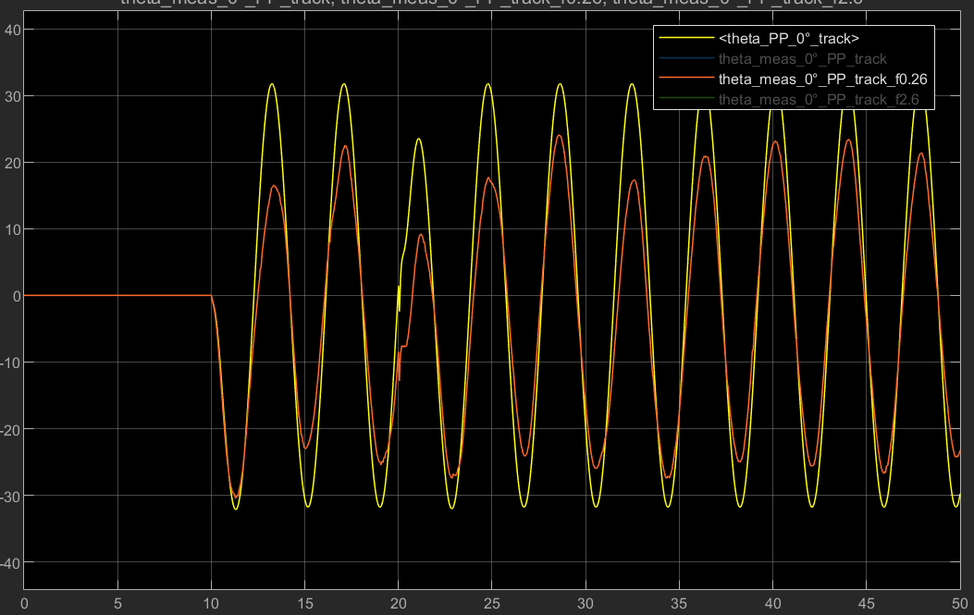As predicted the amplitude of the variation is lower, but the bar is still kept at the downside position, with a small oscillation.

With f = 2.6Hz, beyond the cut-off frequency:

The rod tried to follow the reference, but since it’s too fast, it’s not moving, just small fast oscillation.

Control at the Unstable position

In the Unstable (upside) position the these are the Open loop poles fo the system, there is only on eunstable poles. For Pole Placement it’s better to remove it and also to remove the pole at the origin (as observed in the real syst this pole won’t be able to keep the rod at steady position, but it will move randomly untili t hit the end stop).

Taking also into account of the LQR poles at the upside position, we choose the poles accordingly and slightly changed them:

LQR poles: [-3.09 -4.64+i3.67 -4.64-i3.67 -115.67]

Starting poles: [-0.8 -0.9 -15 -115]

With these poles the response was noisy, the rod is not that steady and so the bar pendulum, even tho the bar is kept at the unstable position, the variation of the rod angle can be high enough to hit the end stop, due to a strong pertutbation, and causing the bar to fall down.

[-5 -5.2 -15 -115]: increasing the first two poles the response was still noisy, but the rod was very responsive againts a perturbation, the control will immediatly act due to a perturbation on the bar so the rod won’t move too much.

[-2 -2.2 -15 -115]: final poles, less noisy to the previous ones, still the rod is very responsive.

The gains obtained: -1.9156 -2.0188 -74.6922 -5.9023

Testing the Step response with the matlab code it seems that the Settling time it would be around 2.5s, but the variation is very small so we can consider the bar to be more or less stable already before that time.

Againts a perturbation on the bar pendulum angle (ϕ): impulse of 15° for about 0.05s

As predicted the bar pendulum is able to reach the unstable position after 1s already with the mathematical model, instead with the real system the response is a bit noisy, there is a random variation of about 2° on ϕ. The real system is not that steady, but is fast to recover from the perturbation.

The rod is not stable and as usual this unstability can be observe on the Voltage referance which variating very fast and reaching the limit of the Voltage input.

Robustness Test

Now let’s see if the Control System is robust due to a variation in the parameters:

* Ir = formula
* α = 0
* Immagine che contiene schermata, testo, Diagramma, Software per la grafica

  Descrizione generata automaticamenteβ = 0

The behavior is more or less the same.

Trajectory Tracking Control

The Control is able to track the sinusoidal signal of amplitude 45° and period T=20s and also to keep the bar at the vertical position.

The bar is not that steady, buti t is kept at the upside position